St. Peter Lutheran Church

Divine Service for the 17th Sunday after Pentecost
Bible Translation Sunday
September 27, 2020

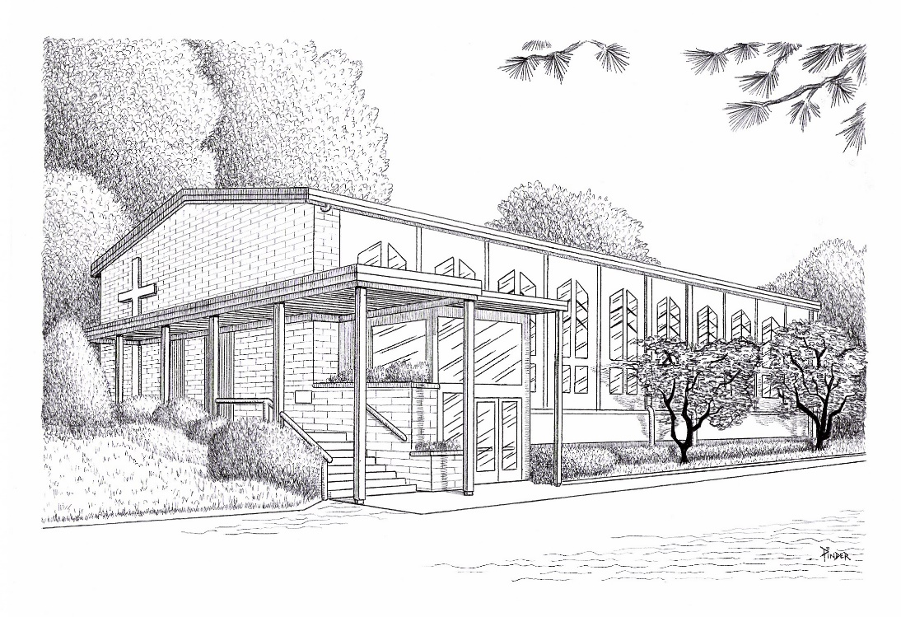

www.stpetersnorwalk.org
(203) 847-1252
email: stpeterlcpastor@yahoo.com office@stpeternorwalk.org

Thy Strong Word LSB 578 sts. 1–6
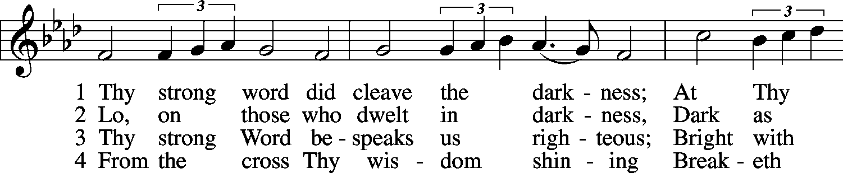
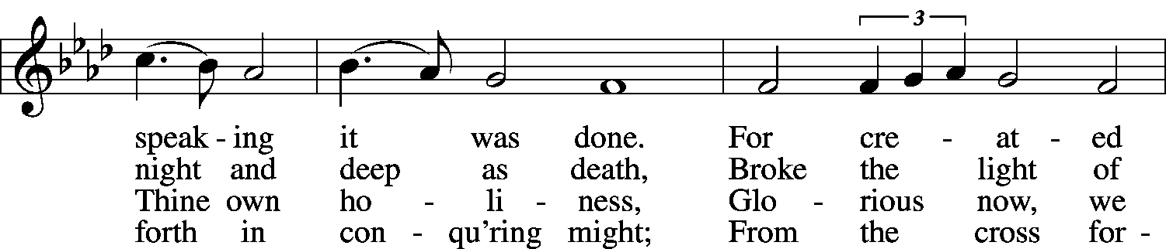
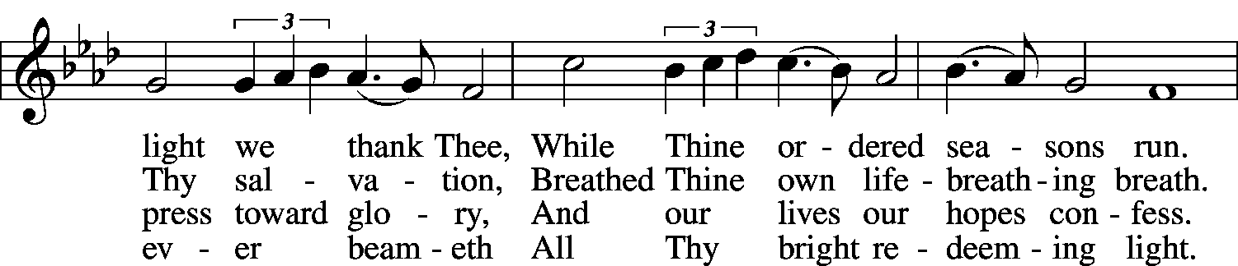
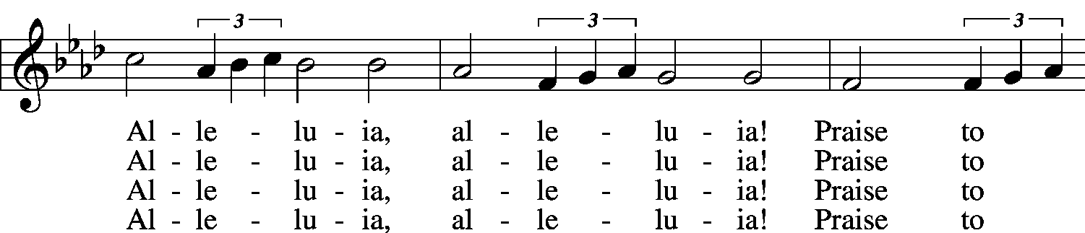
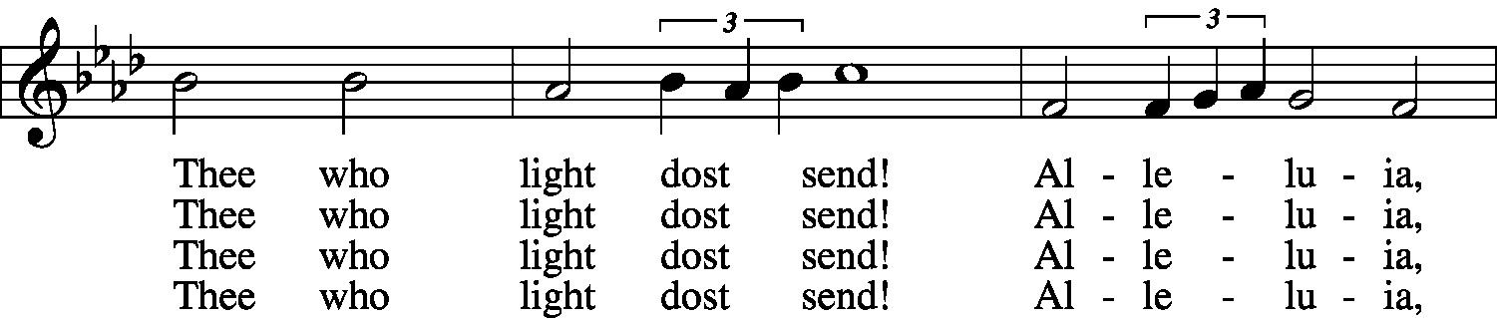
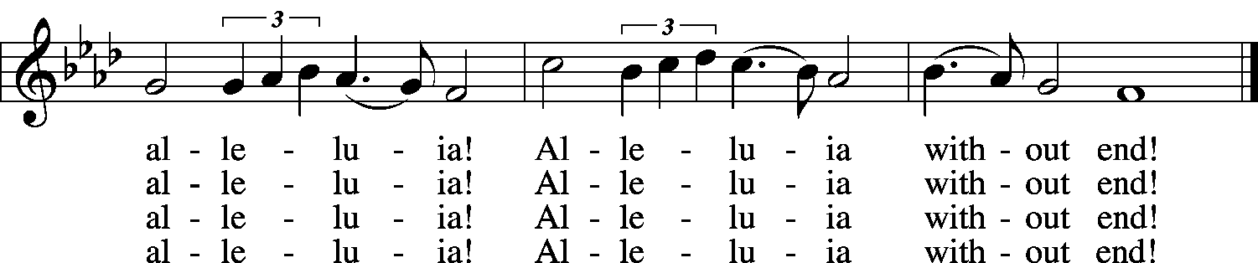

5 Give us lips to sing Thy glory, tongues Thy mercy to proclaim,
Throats that shout the hope that fills us, mouths to speak Thy holy name.
Alleluia, alleluia! May the light which Thou dost send
Fill our songs with alleluias, Alleluias without end!

6 God the Father, light-creator, to Thee laud and honor be.
To Thee, Light of Light begotten, praise be sung eternally.
Holy Spirit, light-revealer, glory, glory be to Thee.
Mortals, angels, now and ever praise the holy Trinity!
© 1969 Concordia Publishing House. Used by permission: LSB Hymn License .NET, no. 100011154. Public domain

P In the name of the Father and of the (+) Son and of the Holy Spirit. Amen.
If we say we have no sin, we deceive ourselves, and the truth is not in us.
C But if we confess our sins, God, who is faithful and just, will forgive our sins and cleanse us from all unrighteousness.
P Let us then confess our sins to God our Father.
C Most merciful God, we confess that we are by nature sinful and unclean. We have sinned against You in thought, word, and deed, by what we have done and by what we have left undone. We have not loved You with our whole heart; we have not loved our neighbors as ourselves. We justly deserve Your present and eternal punishment. For the sake of Your Son, Jesus Christ, have mercy on us. Forgive us, renew us, and lead us, so that we may delight in Your will and walk in Your ways to the glory of Your holy name. Amen.
P Almighty God in His mercy has given His Son to die for you and for His sake forgives you all your sins. As a called and ordained servant of Christ, and by His authority, I therefore forgive you all your sins in the name of the Father and of the (+) Son and of the Holy Spirit. Amen.

Service of the Word
Introit Ps. 119:33-37, 40; antiphon: Ps. 119:105
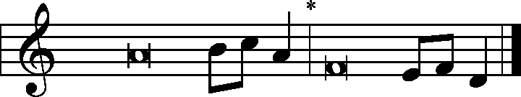
Pastor: Your Word is a lamp | to my feet
and a light | to my path.
People: Teach me, O Lord, the way of your | statutes;
and I will keep it | to the end.
Give me understanding, that I may | keep your law
and observe it with my | whole heart.
Lead me in the path of your com- | mandments,
for I de- | light in it.
Incline my heart to your testi- | monies,
and not to | selfish gain!
Turn my eyes from looking at | worthless things;
and give me life | in your ways.
Behold, I long for your | precepts;
in your righteousness | give me life!
Glory be to the Father and | to the Son
and to the Holy | Spirit;
as it was in the be- | ginning,
is now, and will be forever. | Amen.
Pastor: Your Word is a lamp | to my feet
and a light | to my path.

Kyrie LSB 168
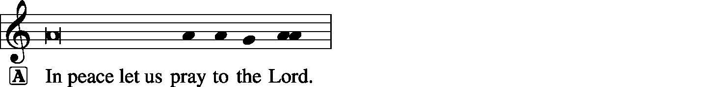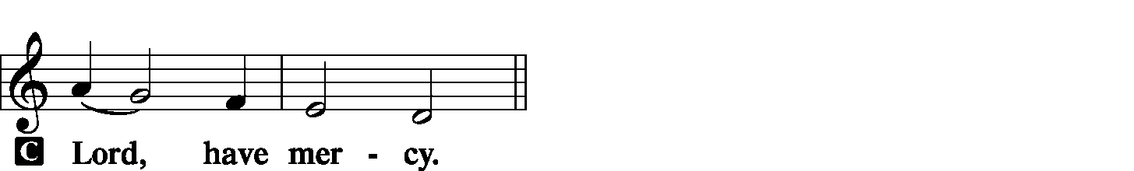

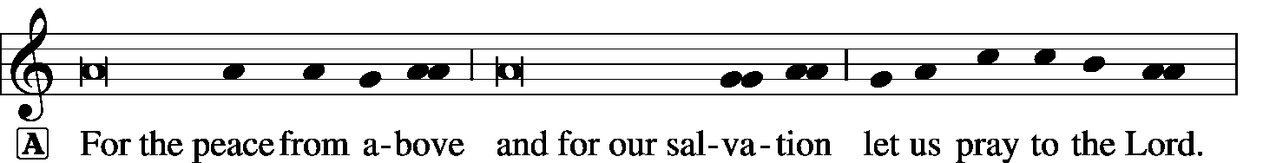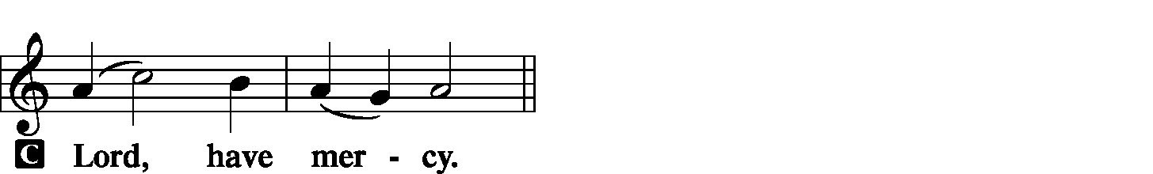
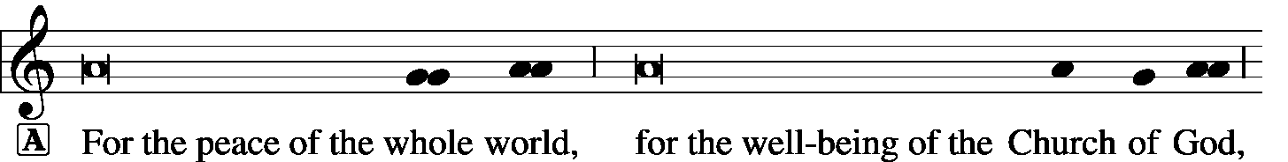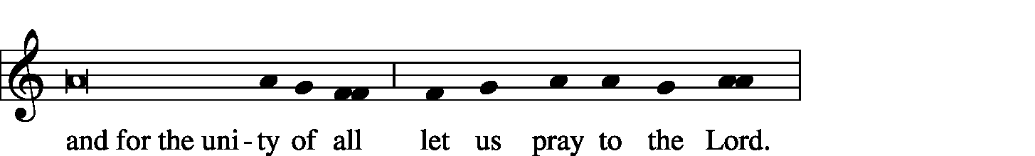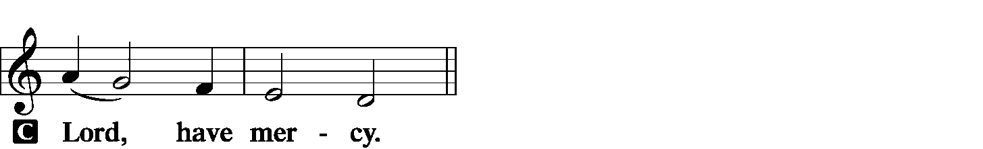
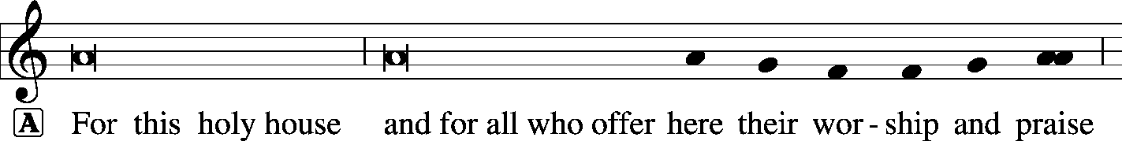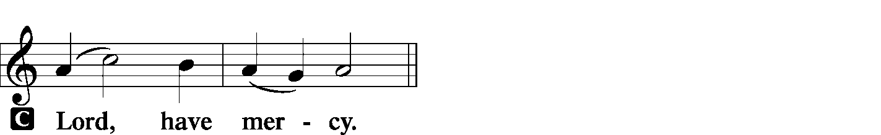



Hymn of Praise – “This is the Feast” LSB 171
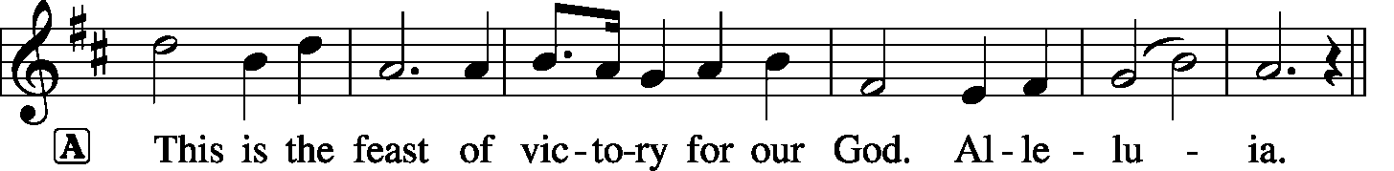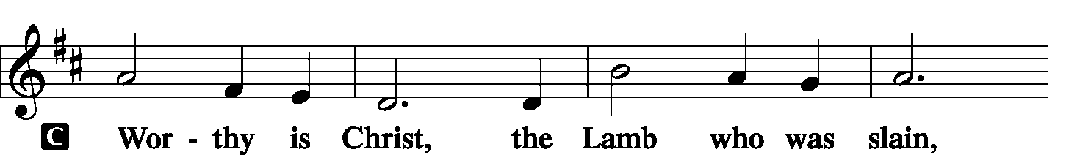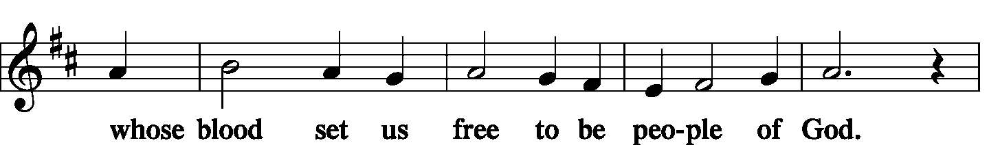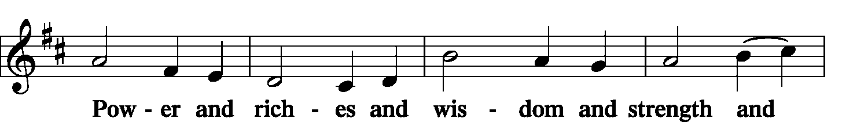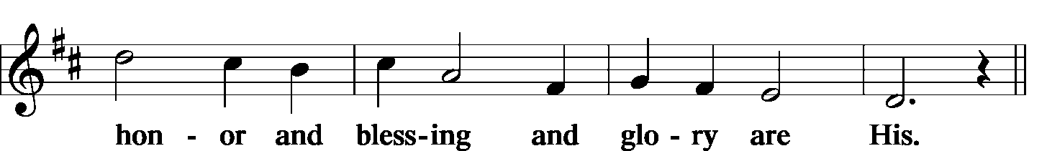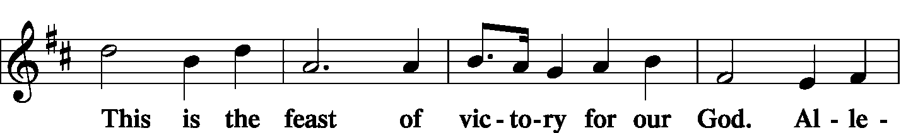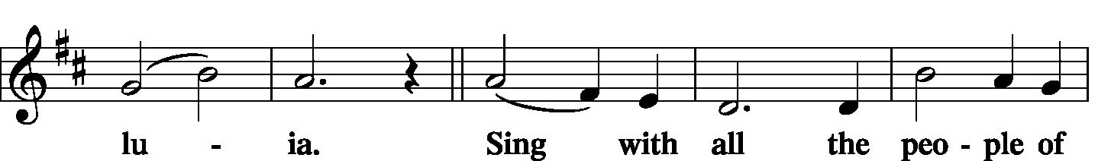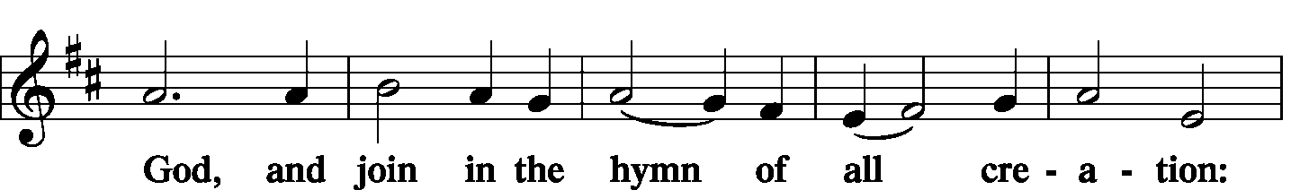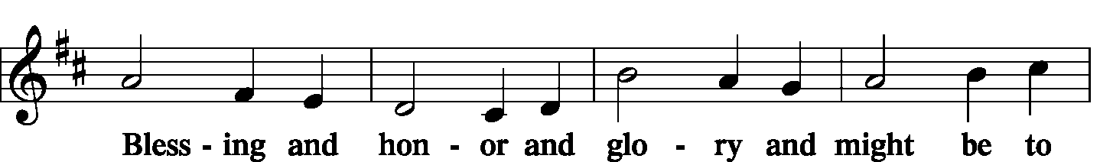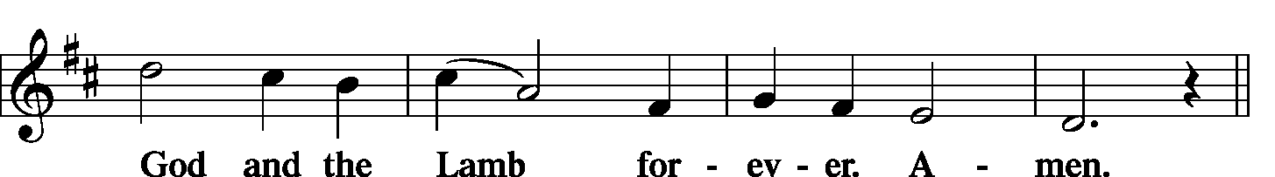
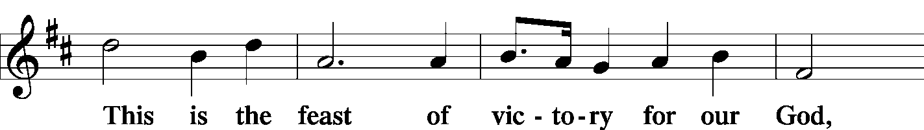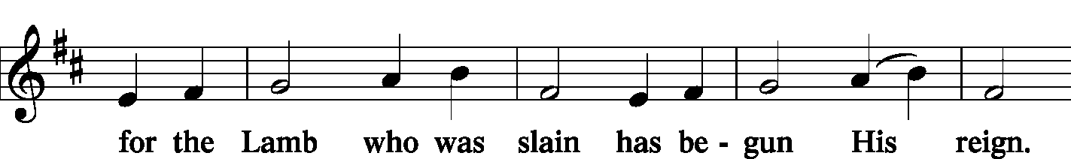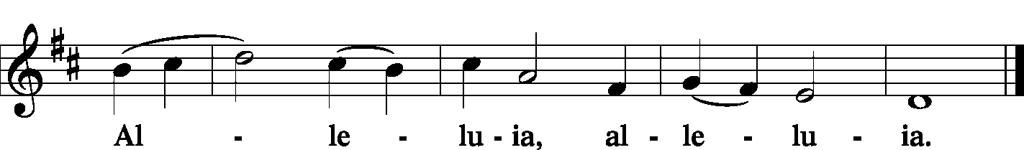

Salutation and Collect of the Day
P | The Lord be with you. C And also with you.
P | Let us pray. Eternal God and Father of our Lord Jesus Christ, grant us Your Holy Spirit who writes the preached Word into our hearts so that we may receive and believe it, and be gladdened and comforted by it into eternity. Glorify Your Word in our hearts. Make it so bright and warm that we may find pleasure in it, and through Your inspiration think what is right. By Your power fulfill the Word, for the sake of Jesus Christ, Your Son, our Lord, who lives and reigns with You and the Holy Spirit, one God, now and forever. Amen.
Old Testament 2 Kings 22:3-13
In the eighteenth year of King Josiah, the king sent Shaphan the son of Azaliah, son of Meshullam, the secretary, to the house of the Lord, saying, “Go up to Hilkiah the high priest, that he may count the money that has been brought into the house of the Lord, which the keepers of the threshold have collected from the people. And let it be given into the hand of the workmen who have the oversight of the house of the Lord, and let them give it to the workmen who are at the house of the Lord, repairing the house (that is, to the carpenters, and to the builders, and to the masons), and let them use it for buying timber and quarried stone to repair the house. But no accounting shall be asked from them for the money that is delivered into their hand, for they deal honestly.”
And Hilkiah the high priest said to Shaphan the secretary, “I have found the Book of the Law in the house of the Lord.” And Hilkiah gave the book to Shaphan, and he read it. And Shaphan the secretary came to the king, and reported to the king, “Your servants have emptied out the money that was found in the house and have delivered it into the hand of the workmen who have the oversight of the house of the Lord.” Then Shaphan the secretary told the king, “Hilkiah the priest has given me a book.” And Shaphan read it before the king.

When the king heard the words of the Book of the Law, he tore his clothes. And the king commanded Hilkiah the priest, and Ahikam the son of Shaphan, and Achbor the son of Micaiah, and Shaphan the secretary, and Asaiah the king's servant, saying, “Go, inquire of the Lord for me, and for the people, and for all Judah, concerning the words of this book that has been found. For great is the wrath of the Lord that is kindled against us, because our fathers have not obeyed the words of this book, to do according to all that is written concerning us.”
P This is the Word of the Lord. C Thanks be to God.

Epistle Philippians 2:1-4, 14-18
So if there is any encouragement in Christ, any comfort from love, any participation in the Spirit, any affection and sympathy, complete my joy by being of the same mind, having the same love, being in full accord and of one mind. Do nothing from rivalry or conceit, but in humility count others more significant than yourselves. Let each of you look not only to his own interests, but also to the interests of others…
Do all things without grumbling or questioning, that you may be blameless and innocent, children of God without blemish in the midst of a crooked and twisted generation, among whom you shine as lights in the world, holding fast to the word of life, so that in the day of Christ I may be proud that I did not run in vain or labor in vain. Even if I am to be poured out as a drink offering upon the sacrificial offering of your faith, I am glad and rejoice with you all. Likewise you also should be glad and rejoice with me.
P This is the Word of the Lord. C Thanks be to God.
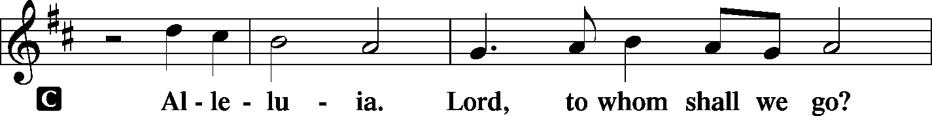
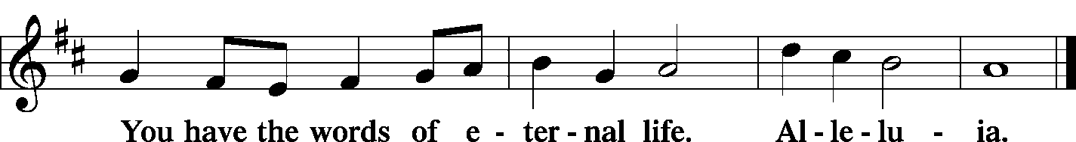

Holy Gospel John 5:31-40
P | The Holy Gospel according to St. John, the 5th chapter.
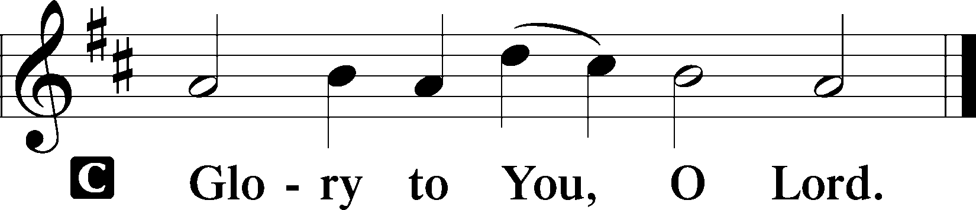

[Jesus said to the Jews:] “If I alone bear witness about myself, my testimony is not true. There is another who bears witness about me, and I know that the testimony that he bears about me is true. You sent to John, and he has borne witness to the truth. Not that the testimony that I receive is from man, but I say these things so that you may be saved. He was a burning and shining lamp, and you were willing to rejoice for a while in his light. But the testimony that I have is greater than that of John. For the works that the Father has given me to accomplish, the very works that I am doing, bear witness about me that the Father has sent me. And the Father who sent me has himself borne witness about me. His voice you have never heard, his form you have never seen, and you do not have his word abiding in you, for you do not believe the one whom he has sent. You search the Scriptures because you think that in them you have eternal life; and it is they that bear witness about me, yet you refuse to come to me that you may have life."
P | This is the Gospel of the Lord.
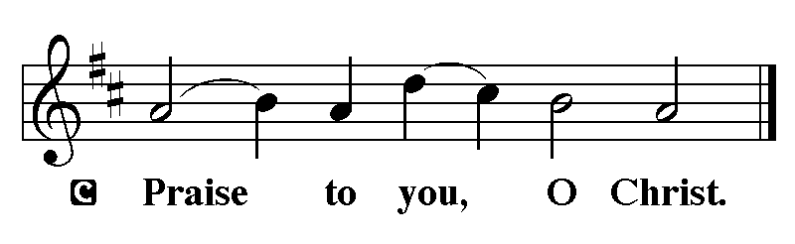

The Nicene Creed
I believe in one God, the Father Almighty, maker of heaven and earth and of
all things visible and invisible.
And in one Lord Jesus Christ, the only-begotten Son of God, begotten of His
Father before all worlds, God of God, Light of Light, very God of very God, begotten, not made, being of one substance with the Father, by whom all things were made; who for us men and for our salvation came down from heaven and was incarnate by the Holy Spirit of the virgin Mary and was made man; and was crucified also for us under Pontius Pilate. He suffered and was buried. And the third day He rose again according to the Scriptures and ascended into heaven and sits at the right hand of the Father. And He will come again with glory to judge both the living and the dead, whose kingdom will have no end.
And I believe in the Holy Spirit, the Lord and giver of life, who proceeds from
the Father and the Son, who with the Father and the Son together is worshiped and glorified, who spoke by the prophets. And I believe in one holy Christian and apostolic Church, I acknowledge one baptism for the remission of sins, and I look for the resurrection of the dead and the life of the world to come. Amen.

"How Shall They Hear," Who Have Not Heard LSB 831
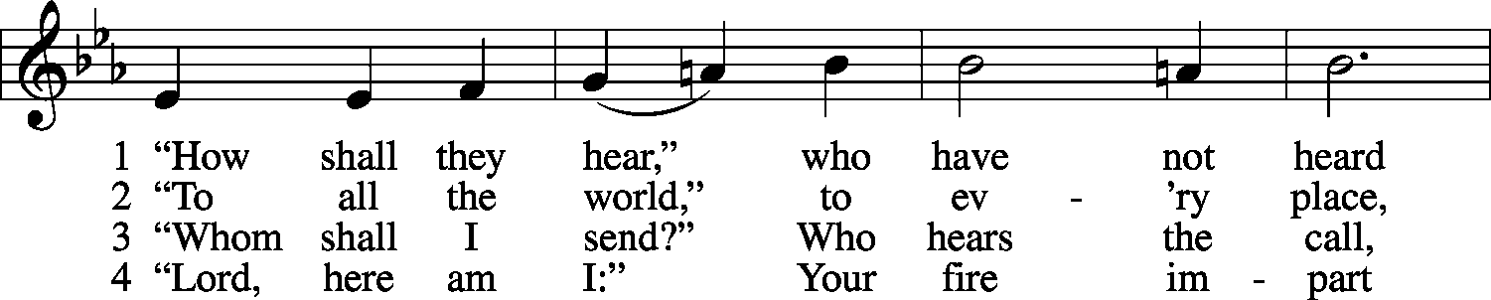
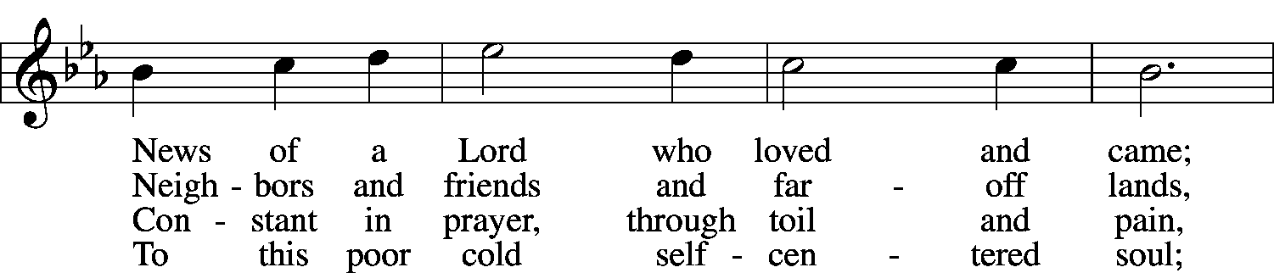
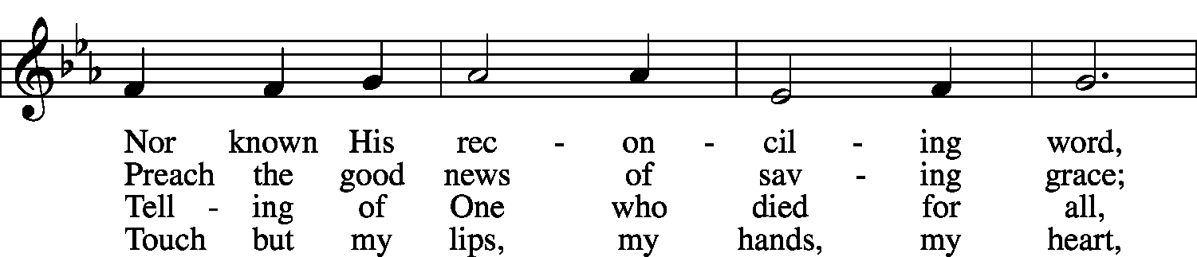
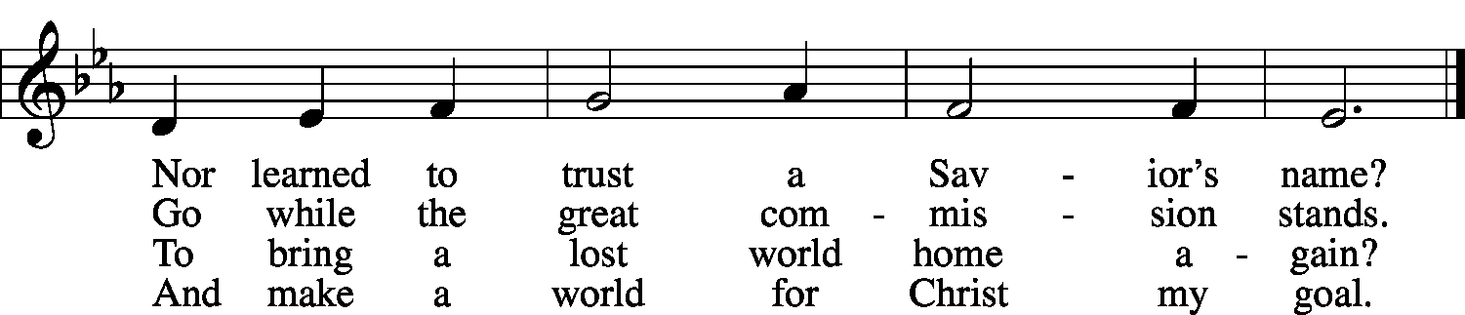

5 Spirit of love, within us move:
Spirit of truth, in pow’r come down!
So shall they hear and find and prove
Christ is their life, their joy, their crown.
© 1984 Hope Publishing Co. Used by permission: LSB Hymn License .NET, no. 100011154. Public domain
Sermon & Prayers

Service of the Sacrament
Preface LSB 177

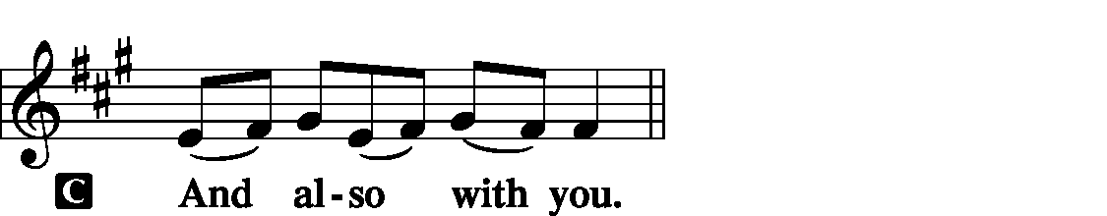
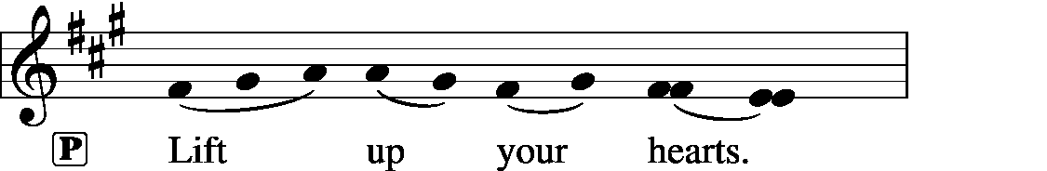

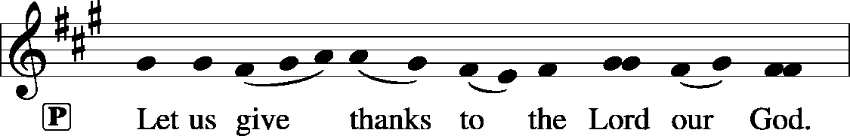
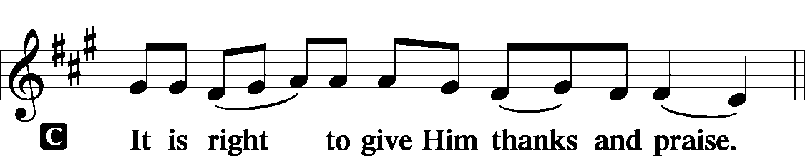

Proper Preface
P It is truly good, right, and salutary… evermore praising You and saying:
Sanctus LSB 178
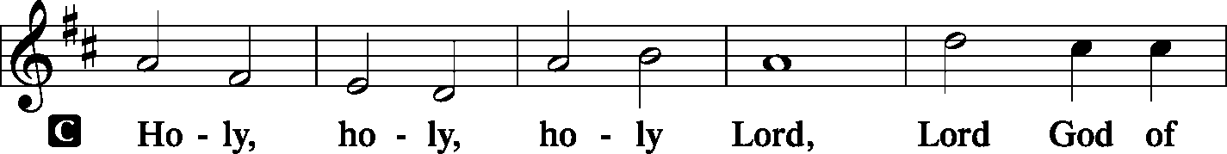
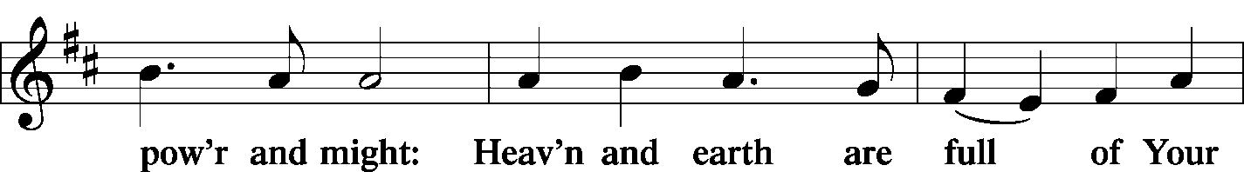
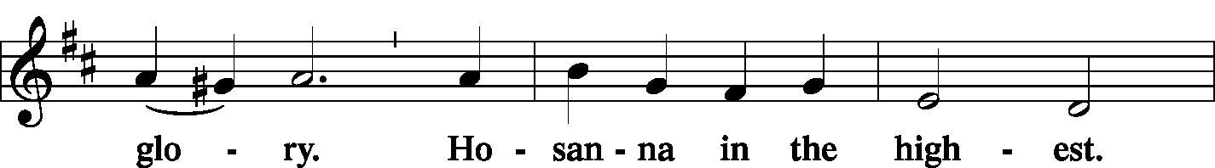
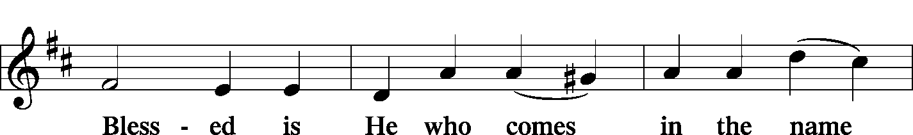
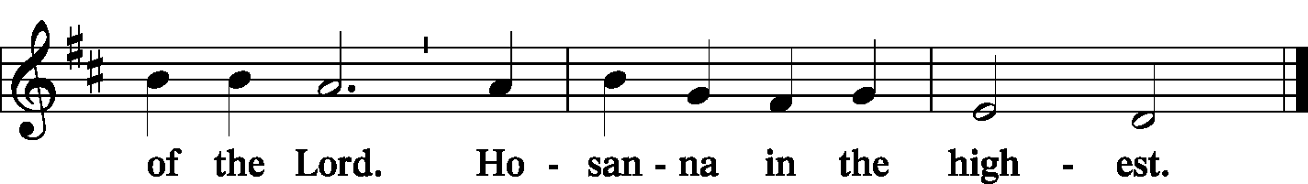
Prayer of Thanksgiving LSB 178
P Blessed are You, Lord of heaven and earth,… To You alone, O Father, be all glory, honor, and worship, with the Son and the Holy Spirit, one God, now and forever. Amen.
P Lord, remember us in Your kingdom and teach us to pray: Our Father…

The Words of Our Lord
P | Our Lord Jesus Christ, on the night when He was betrayed, took bread, and when He had given thanks, He broke it and gave it to the disciples and said: “Take, eat; this is My (+) body, which is given for you. This do in remembrance of Me.”
P | In the same way also He took the cup after supper, and when He had given thanks, He gave it to them, saying: “Drink of it, all of you; this cup is the new testament in My (+) blood, which is shed for you for the forgiveness of sins. This do, as often as you drink it, in remembrance of Me.”

Pax Domini LSB 180
P The peace of the Lord be with you always.


Agnus Dei LSB 180
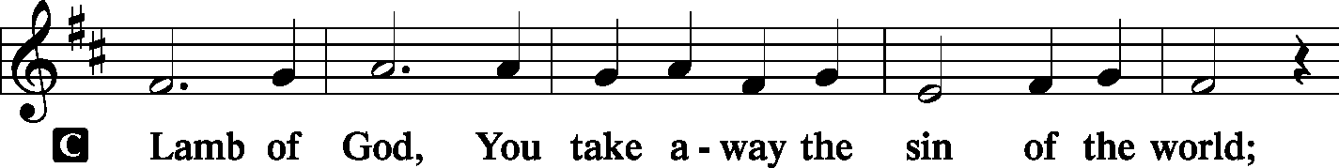
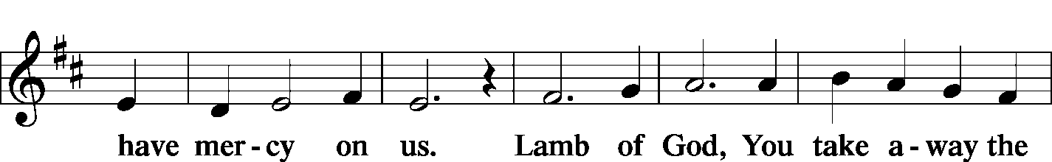
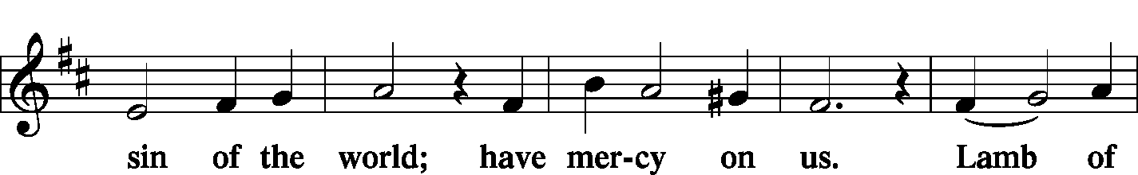
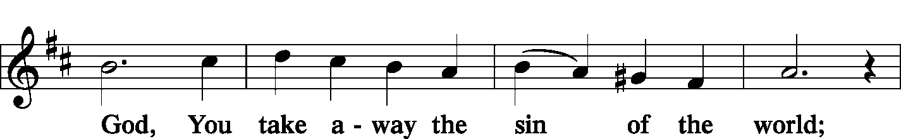
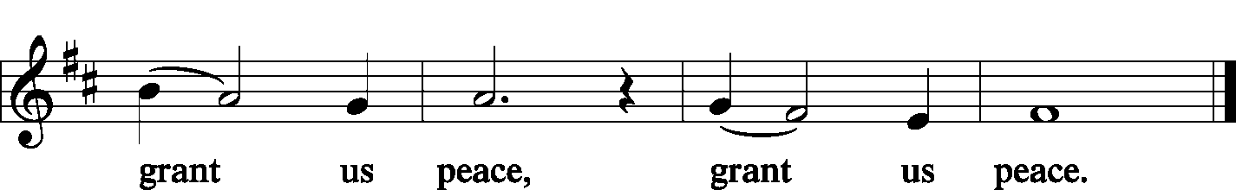

The Distribution of Holy Communion

Holy Communion will be distributed by Pastor up front, before the railing. Line up single file (observing social distancing) and step forward to receive the body of Christ from Pastor, and then step to the side to take an individual cup with the blood of Christ from the tray. After receiving, deposit your cup in the pitchers on either side.

As with all other blessings of God, the faith that receives Christ in this Sacrament rests upon His Word. Sadly, there is much division and disagreement in Christianity today regarding many teachings of the Scriptures, including this Sacrament. For this reason, we in the Lutheran Church – Missouri Synod ask that those communing with us first be instructed in our faith before receiving communion. Our desire is that all who commune might receive Christ and commune with one another to their blessing. Thank you for your understanding.

Post-Communion Canticle – “Thank the Lord” LSB 181
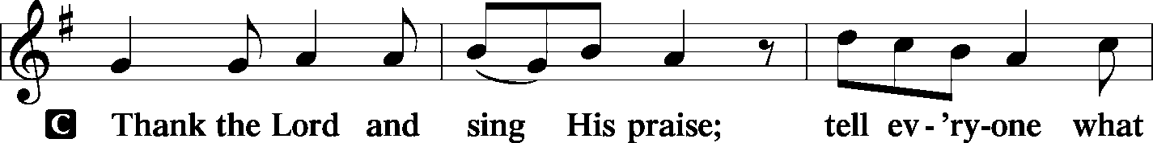
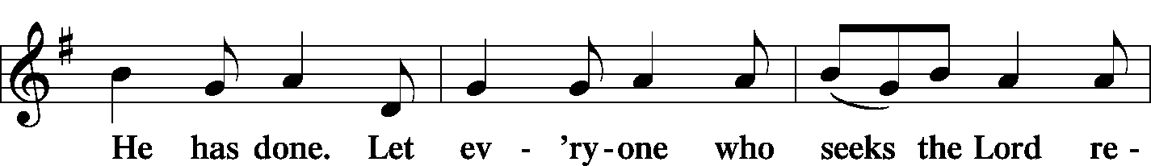
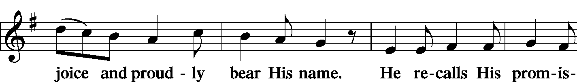
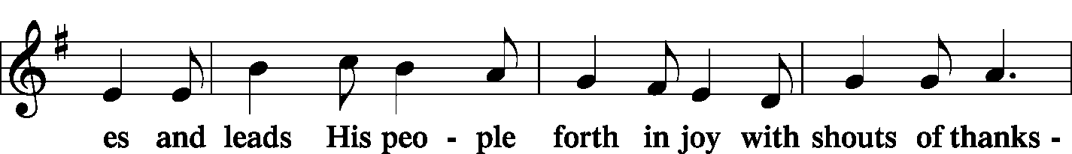
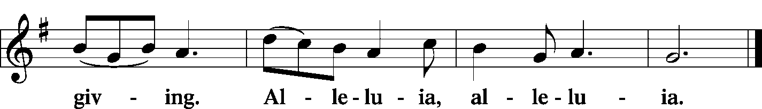

Post-Communion Collect
P | Let us pray. We give thanks to You, almighty God, … now and forever. Amen.
 | The Lord bless you and keep you… and give you peace.
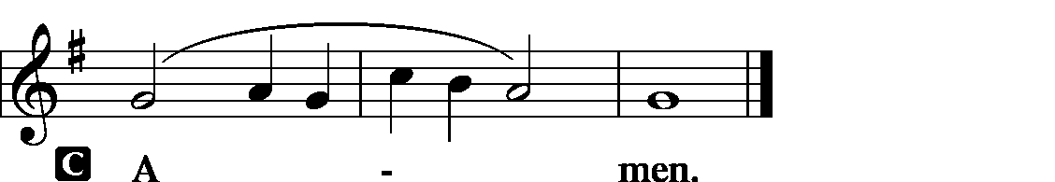

God Has Spoken by His Prophets Public domain LSB 583
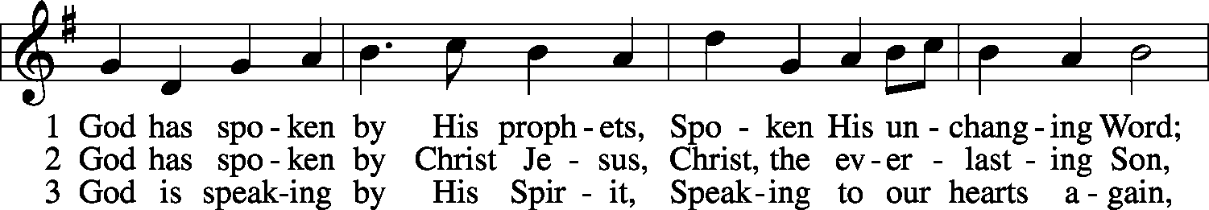
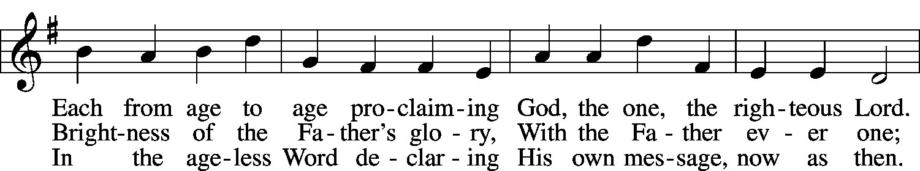
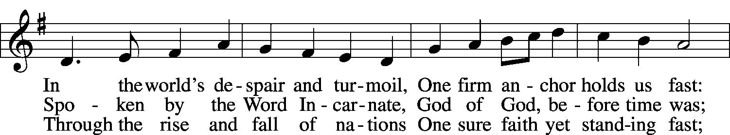
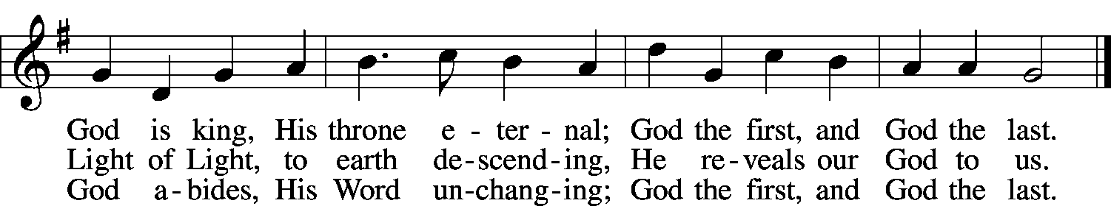
© 1953, renewed 1981 The Hymn Society; admin. Hope Publishing Co. Used by permission: LSB Hymn License .NET, no. 100011154.

Acknowledgments
Divine Service, Setting Two from Lutheran Service Book
Unless otherwise indicated, all scripture quotations are from The Holy Bible, English Standard Version, copyright © 2001 by Crossway Bibles, a division of Good News Publishers. Used by permission. All rights reserved.
Created by Lutheran Service Builder © 2006 Concordia Publishing House.

