Advent 1, C (Thanksgiving) – November 25, 2021
Scriptures – Ps. 103; Habakkuk 3:17-19; 1 Thess. 3:9-13; Luke 12:13-21

Though the fig tree should not blossom, nor fruit be on the vines, the produce of the olive fail and the fields yield no food, the flock be cut off from the fold and there be no herd in the stalls, yet I will rejoice in the Lord; I will take joy in the God of my salvation. Hab. 3

On Thanksgiving Day my local newspaper had this cartoon on the editorial page. I’m guessing it was a slap at Facebook, which in testimony before Congress recently was accused of putting profits before people and harming children by steering them towards damaging content. Facebook is now being rebranded as Meta, for it will use the Metaverse – technology which uses virtual reality or augmented reality – to make its images more life-like and vibrant… and, like turkeys wearing virtual reality goggles, lead people more easily to the hatchet. Well, I think the cartoon describes life in general today. Technology is used – by the entertainment industry, certainly; but also by advertisers and politicians and many others – to blind people to the realities of life, and especially to the judgments and the mercies of God. They end up unaware and unprepared when the hatchet falls. But, we have our Lord, present among us in His Word and Sacraments. He does not leave us unprepared! And so, with Martin Rinckart, who wrote the hymn we just sang, we say:
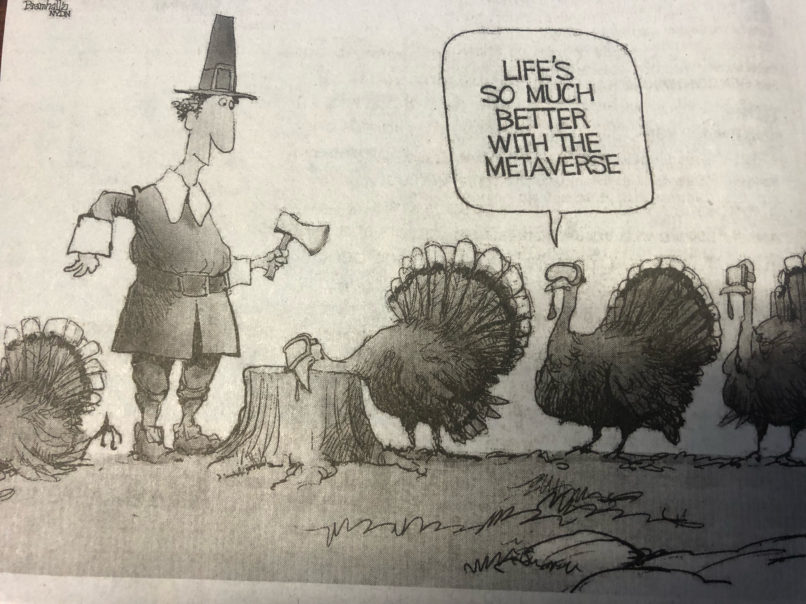
Now – Yes, Now – Thank We All Our God!
Now… no matter what life is bringing.

Martin Rinckart, who wrote the hymn, Now Thank We All Our God, knew how severely the hatchet can fall in this life. He was a Pastor in Eilenburg, Germany, and began his ministry as the Thirty Years’ War broke out in 1618. Historians say it was the most destructive war ever fought in Germany, even worse than WW’s I and II. Destruction and devastation filled the land. Throughout the war Rinckart had to quarter soldiers in his house and endure the frequent plundering of his grain and household goods. Then, in 1637 the plague struck Eilenburg while the town was crowded with refugees. Over 8,000 died in that year, including most of the town council, many school children, and all the other Lutheran clergymen. Rinckart alone ministered to the sick and dying. He buried more than 4,000 people in 1637, often 40-50/day; including his wife. A famine followed that was so extreme crowds would fight for a dead cat or crow. Rinckart did what he could to help, and gave away everything but the barest rations for his own family, so that his door was surrounded by a crowd of starving wretches.

Few of us have endured such things. But, the hatchet of suffering strikes us all in this life. Some of you have faced deprivation and worry because of job loss. Others have dealt with severe illness and had your hopes and dreams dashed. Imagine being a farmer or rancher and hearing Habakkuk speak of “the fig tree not blossoming, nor fruit being on the vines, the produce of the olive failing and the fields yielding no food, the flock being cut off from the fold and there being no herd in the stalls.” The hatchet falls often in this life and at times cuts us severely. Even so, Habakkuk says, and Martin Rinckart sings: we can now – even now – give thanks to God!

How? Well, the crops and herds fail usually because of lack of rain, or an insect infestation… and these things are in God’s control, aren’t they? The hatchet is in God’s hand, you see… and this is a blessing; at least, it is if you know Him. Habakkuk says, “Though the fig tree should not blossom… yet I will rejoice in the Lord; I will take joy in the God of my salvation.” Who is God? You can say with Habakkuk, “He is the God of my salvation.”
- He is the Father who sent His only-begotten Son into the flesh for your salvation. He gave up His Son into death to make us dying sinners His eternal sons and daughters! He is a God of love!
- He is the Son who willingly stepped before the hatchet of God’s hatred of the sins we have committed and put His own head on the chopping block. He was cut off for your sins, that you might be free of them and live! He is a God of mercy!
- He is the Holy Spirit, who came to you in your baptism to fill you and live within you and make you holy. For most of us this happened when we were infants who did not know God at all and could do nothing for Him. He is a God of grace!
This is our God, the God of our salvation. We praise and thank Him because, as Psalm 103 says, He does not deal with us as our sins deserve but shows compassion as a father does to his child. Even though we feel the hatchet in this life, because it is in His hand it will work for our eternal good. It will do so even when He uses it to cut off things that are precious to us. He is tearing the virtual reality goggles from our eyes so that we see the true reality of our mortality. God humbles us, so that, like the 10 lepers, we fall before Him and cry out for mercy to Jesus. Then, because of Jesus, blessing will come; always. As Habakkuk says, like a deer we will “tread on our high places.” God will help us to walk securely and not fall.

Right now, in this life, we can say this only by faith. For, we often don’t see this. The hatchet cuts and hurts severely. One day it will cut us off completely from this life by death. But, even then you can confidently say, “God, the Lord, is my strength; he makes my feet like the deer's; he makes me tread on my high places.” You can confidently say this because of Christ; because all of your sins are borne and taken away by Him, and so God will only and always deal with you in mercy and not anger. Faith is thankful confidence in Christ. It is what we see in the Samaritan leper.

You know, all ten lepers had a great blessing to enjoy after Jesus healed them. Their lives were transformed! Nine of them fixed their eyes on this and ran off to enjoy the great blessing they had received.

Many do this today, even many who claim to believe in Jesus. God blesses everyone in many ways in this life, and this holiday weekend is a good time to remember this and praise Him for this. Only one leper, however, acknowledged Jesus as His Master with his heart by falling before Him with thanks and praise… with worship. A Samaritan, he had formerly followed a different God than had his Jewish brethren. But now he bowed before Jesus and praised Him as his Savior. Although his healing promised to restore much to him – family… friends… his place in his society – he could lose this by turning away from his former faith and worship to worship Jesus.

But he fixed his eyes on Jesus. He believed that He was his Savior, the source of His blessing. He held to Jesus in faith, and his faith was praised by Jesus. So it will be for you as you by faith hold to Jesus.

I close with these words of Martin Luther: “Christendom will not be known by sight, but by faith. And faith has to do with things not seen, Heb. 11:1 says… [And so,] a Christian is hidden even from himself; he does not see his holiness and virtue, but sees in himself nothing but unholiness and vice. [But] our holiness is in heaven, where Christ is; and not in the world, before men’s eyes, like goods in the market place. Therefore let there be offenses, divisions, faults, [and sufferings]; let them do what they can! If only the word of the Gospel remains pure among us, and we love and cherish it, we shall not doubt that Christ is with us, even when things are at their worst.” (LW 36:40) Even then, we will sing: now thank we all our God! In the name of Jesus. Amen.

