PENTECOST 11, C – August 21, 2022
SCRIPTURES – Isaiah 66:18-23; Heb. 12:4-24; Luke 13:22-30

Someone said to him, “Lord, will those who are saved be few?” He said to them, “Strive to enter through the narrow door. For many, I tell you, will seek to enter and will not be able.” Luke 13
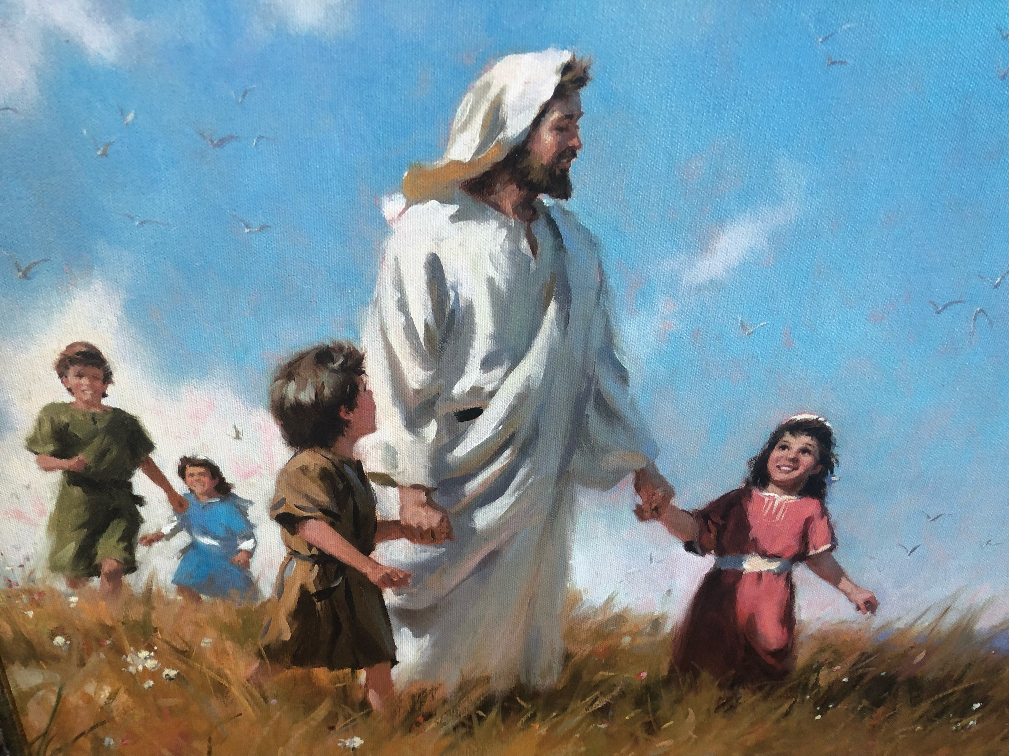
Have you ever wondered what Jesus was like? We have a beautiful picture on the wall of the church office, of Jesus walking through a field, smiling, and walking hand in hand with happy children. That’s a wonderful way to think of Jesus: as gentle, loving, and joyful as He proclaims and shares the peace of God.

Is that the picture the Scriptures paint of Jesus? Sometimes… but not today. A man asks Him a simple, yet serious, question: “Lord, will those who are saved be few?” And Jesus responds, “You” – all of you; it’s plural in the Greek text, indicating that Jesus is speaking not only to the man but also to the crowd that is with Him – “strive [agonidzomai is the Greek word: “agonize, struggle, fight”] to enter through the narrow door. For many, I tell you, will seek to enter and will not be able.” I can see Jesus in the man’s face, sticking His finger in his chest to emphasize His point. He’s confrontational… intimidating… intense in His response to his question. Why?

Well, He wasn’t asked about some obscure issue that really doesn’t matter; such as, “Did Adam and Eve have navels?” Saved, living with God in endless joy in heaven; or not saved, living endlessly without God, without joy, with eternal sadness and grief and regret… in hell, where there is nothing but “weeping and gnashing of teeth” – what could be more important? Did the man who asked see it that way? Did the crowd who was with him? Do you?

God isn’t a theoretical being or an uninterested, unconcerned and unconcerning spirit up above. He is the “Master of the house,” Jesus says: of His eternal house of heaven, sure; but also of this temporary house, this world in which we live for a short while. He is present and active in both houses. We live in His presence!

This is emphasized throughout the Bible. God says of His people in Isaiah 66, “I know their works and their thoughts.” He knows yours, also! He is looking upon you right now! He goes on to say, “I will set a sign among them… I will send survivors to the nations… I will take some of them for priests and for Levites.” How active is God among us! He’s not just looking on and doing nothing!

He is especially active in Jesus. When Jesus answers the man’s question He is not only claiming to know who will go to heaven and who will not; He speaks as being there, as seeing who goes through the narrow door. He speaks as the Master of the house! In fact, He had already said this very plainly. During an earlier visit to Jerusalem He had said: “I am the door. If anyone enters by me, he will be saved.” (John 10:9) Jesus, then, is our eternal life! Our God, the source of life… now among us in our flesh!

Do you believe this? Well, frankly, whether you do or not doesn’t change God. He is active among us, seeking to bring His good rule into our hearts and make your heart His home, His dwelling place on earth. Jesus was willing to get into people’s faces and intimidate them to bring this about, to bring them to believe in Him as their God and Savior. He did so even though most would end up rejecting Him, and even demand that Pilate, the Roman governor, crucify Him.

But, how could this be? If He’s God, how could He be crucified? And, how could He allow His saving work among us to be ended that way? But that was not the end of Jesus’ work. His death was, in fact, the culmination, the very essence of His work. Jesus revealed this not long after this day on which He was asked whether those who were being saved would be few. His disciples, you see, got into an argument about which of them was the greatest. So, He told them: “whoever would be great among you must be your servant, and whoever would be first among you must be your slave, even as the Son of Man came not to be served but to serve, and to give his life as a ransom for many.” (Matt. 20:26-28) His life wouldn’t be taken. He would give it. He would give it as a ransom, a payment to set us free from our sins and restore us to God. The author of Hebrews therefore says that Jesus is “the mediator of a new covenant,” and His death on the cross is “the sprinkled blood that speaks a better word than the blood of Abel.” (Heb. 12:24) Abel was killed by his brother out of jealousy, and his blood cried out to God for vengeance. Christ’s blood cries out for our forgiveness. He made this clear by what He said as they were nailing Him to the cross: “Father, forgive them, for they know not what they do.”

Jesus answered the man’s question about being saved by putting it in the present: “Strive to enter through the narrow door.” Salvation is among you now, for Jesus is present! The door is open now! Enter it!

You don’t enter merely by being a good person, and even being religious. Such things, although good and important, do not save. Jesus makes this clear when He says that those who find the door shut to them will say to the Master of the house, “We ate and drank in your presence, and you taught in our streets.” They were religious! They went to church. They ate and drank in His presence and heard God. But, notice: they don’t say, “You taught us.” Their relationship with Him was from a distance. And so, they will hear, “I tell you, I do not know where you come from. Depart from me, all you workers of evil!”

What saves? Who receives eternal life in Christ? Faith: believing the truth about God, that He is present among us and active for us in Jesus; and so acting on that faith by seeking Him and receiving Him – this saves.
- And so, baptism saves: not because it’s a nice rite of passage, one that we can record with pictures to look back upon later. It saves because it is “the sprinkled blood [of Jesus] that speaks a better word than the blood of Abel.” It speaks forgiveness. Those who receive it in this faith are saved.
- Coming to church also saves: not because we can say that we obeyed God, and certainly not because we can then slap each other on our backs and congratulate ourselves for being good. It saves because here “the sprinkled blood [of Jesus] speaks” for our forgiveness. Jesus is present and active among us here! If you believe this and gladly receive Him and His forgiveness you receive His salvation! God knows you in Him and will welcome you into His kingdom.

Such faith changes how you see Jesus. Even when He is stern and confrontational and intimidating, as He was with the man who asked Him, “Lord, will those who are saved be few?” it is because He loves us and wants nothing to separate us from Him. See this. See your eternal life and salvation as Jesus sees it: as deadly serious, as worthy of dying for. He died for you and obtained eternal life for you. Believe this and receive Him, and when He, the Master of the house returns, you will be among those who “come from east and west, and from north and south, and recline at table in the kingdom of God.”

In the name of Jesus, our eternal Savior. Amen.

